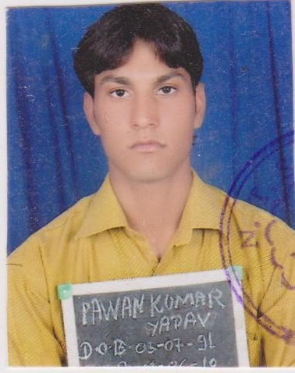  Pawan Kumar Yadav  Email:pawanyadavlucky07@gmail.com  CONTACT ADDRESS  Pawan Kumar Yadav S/0 Shri Ram Kishor Yadav  Village/post-Natha Ki nangal, Teh.-Neem ka Thana, dist.-Sikar (Raj.)  Pin : - 332711  Mobile: +91-9782070818  9785299347  PERSONAL DATA  Born on…  .July 05 1991  Nationality…  - Indian  Languages known…  - English  - Hindi  Hobby…  - Reading Books  - Playing Volleyball & computer games,  - Complete time internet working  - Search new guideline  Marital status…  - Single  Father…  - Mr.Ram kishor yadav  Mother…  - Mrs. Krishana Devi | I AM…  Looking for a position in a result-oriented organization where acquired skills and education will be utilized towards continuous growth and advancement and also provide opportunity to learn new technologies.  I AM…  I have complete graduation in B.TECH of Government Engineering College, Jhalawar, in Computer Science Engineering.  MY EDUCATION  - B.Tech. ( Computer Science Engineering)  With 66%in 1st semester  57.4% in 2nd semester  57.8% in 3rd semester  60.1%in 4th semester  66.3% in 5th semester  65.8% in 6th semester  69.56% in 7th semester  70.20% in 8th semester.  Agg.63.35  From Rajasthan Technical University, Kota.  - HIGH SECONDARY  With 59.23%from Rajasthan Board, 2008  - SECONDARY  With 56.50% from Rajasthan Board, 2006.  TRAINING :  Training in Creativeminds.net & Development Center Jaipur (Rajasthan) In WordPress, open cart, html, Html5, Css, Java Script, JQuery.  ADDITIONAL  - Basic Knowledge of Computer  - Web Design & Development ( Magneto, WordPress CMS, Open cart, )  - Html5,Css,Java Script ,JQuery  - Graphics Basic  - Design Tools :- Photoshop CS 6 ,Visual Composer (wp)  - Responsive web Design and light Wait ,  - Mobile visibility

Experience
I have two year experience in website development an designing various platforms like magento, opencart , HTML5 and wordpress. Apart from this I also do SEO and SMO of websites.

My Practical Knowledge & Skills
- Search Engine Optimization (SEO) & SMO.
- Web Design and Development (Magneto, WordPress, open cart, Joomla, BlogSpot’s).
- Web Sites Cpanel Setup & Configurations Skills.

- CMS (MAGENTO ,WORDPRESS, OPENCART,)

My Live Project
- Besthoteljodhpur.com (Live Website)
- www.antiqueindiafurniture.com
- bhadra.gauravjyoti.com
- www.gemstonesilverjewellery.com
- www.grandtayabyregis.com
- www.indiastoneshub.com
- www.jaipurphysiotherapy.com
- www.lakendresortudaipur.com
- www.rananjayexports.com
- www.silverjewelleryjaipur.in
- www.inlayfurnitureinc.com
- www.larimar925jewelry.com
- www.theindiangoldentriangle.com
- www.themagicmirror.in
- www.theregishotels.com

EXTRA CURRICULAR ACTIVIES
- Certificate-Discipline volunteers (DISCP. & EXTRA CUR.ACTIVITY).
- Certificate-Ethical hacking Workshop.
- Certificate –sports (in Volleyball).
- Certificate –Linux operating system.
- Certificate-core java.
- Certificate –android.
- Certificate –CCNA.(cisco networking analysis)

STRENGTHS
- Proven abilities of working as a responsible and Efficient Team Member.
- Hardworking & Quick Learner.
- Self-Motivated and good communication skills.
- Disciplined and Punctual.
- I never leave the things being half done.
- Can Adapt in Any Environment, Good Listener

DECLARATION
I here by declare that the above information mentioned is correct to the best of my knowledge and belief.
Place: Sikar
Date:06.06.2016
SIGNATURE
